FACEBOOK COPY | IMAGE (THUMBNAIL)
February means hearts, candy and… condoms? Yep, it’s National Condom Month. So, make February – and every month – the time to talk with your partner about safe sex. Condoms are easy to find and don’t have to cost you a cent. Find free condoms in your area at https://www.myiacondoms.org. | 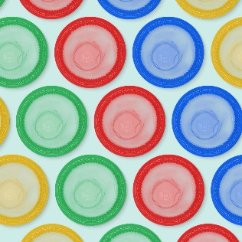
TRUE or FALSE: Condoms are the best way to prevent STIs and an unplanned pregnancy.  FALSE: Abstinence is the only way to prevent both. But condoms are the next best choice! If things are heating up with your partner, make sure you have condoms handy. Go to https://myiacondoms.org to find them for free in your area. | 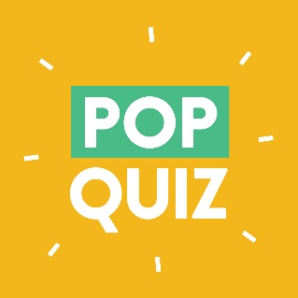
Have a special new someone in your life? Before you jump into bed, ask your partner 3 simple questions:
- Are you ready for sex?
- Are you aware of ALL potential outcomes, good and bad?
- Do you have condoms handy?
Because, what’s more awkward: talking about safe sex or talking about STIs/STDs?

This Valentine’s Day, we’ve got you covered! Find free condoms at https://www.myiacondoms.org. Because, nothing says “love” like wearing a glove. | 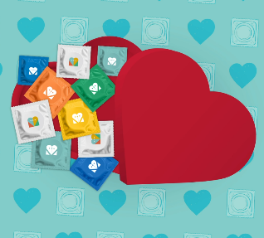
Safe sex starts with a 4-letter word: FREE! February is National Condom Month, which means it’s a great time to talk to your partner about using condoms. Find FREE condoms in your area at https://www.myiacondoms.org.

Did you know that condoms are cheaper than:
- An extra side of guac from your favorite restaurant?
- Your large, triple, half-sweet, non-fat caramel macchiato?
- Diapers from an unplanned pregnancy?
It’s true! Find FREE condoms at https://www.myiacondoms.org.
When it comes to talking about sex, what’s more awkward: talking with your partner about using condoms, or talking with your partner about an STI or even an unplanned pregnancy? For more safe-sex conversation starters, visit https://pcaiowa.org/lets-talk-teens.

Well, Iowa – that’s a wrap for National Condom Month. Remember these two ways to prevent STIs/STDs and unplanned pregnancies:  - Abstinence  - Condoms  Talk to your partner about using condoms or other contraceptives before you have sex. And get FREE condoms at https://www.myiacondoms.org. | 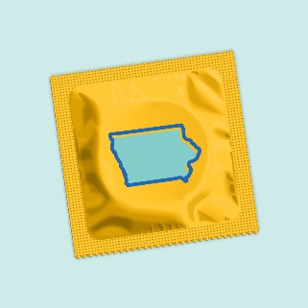

INSTAGRAM | IMAGE (THUMBNAIL)
February means hearts, candy and… condoms? Yep, it’s National Condom Month. So, make February – and every month – the time to talk with your partner about safe sex. Condoms are easy to find and don’t have to cost you a cent. Find free condoms in your area at MyIAcondoms.org
#nationalcondommonth #hearts #candy #free #condoms #freecondoms #safesex #iowa #wrapitup
TRUE or FALSE: Condoms are the best way to prevent STIs and an unplanned pregnancy.
FALSE: Abstinence is the only way to prevent both. But condoms are the next best choice! If things are heating up with your partner, make sure you have condoms handy. Go to MyIACondoms.org to find them for free in your area.
#nationalcondommonth #free #condoms #freecondoms #safesex #abstinence #pregnancy #iowa #wrapitup
Have a special new someone in your life? Before you jump into bed, ask your partner 3 simple questions:
- Are you ready for sex?
- Are you aware of ALL potential outcomes, good and bad?
- Do you have condoms handy?
Because, what’s more awkward: talking about safe sex or talking about STIs/STDs?
#nationalcondommonth #free #condoms #freecondoms #safesex #iowa #wrapitup #sti #std
This Valentine’s Day, we’ve got you covered! Find free condoms at MyIAcondoms.org. Because, nothing says “love” like wearing a glove.
#love #happyvalentinesday #nationalcondommonth #free #condoms #freecondoms #safesex #iowa #wrapitup
Safe sex starts with a 4-letter word: FREE! February is National Condom Month, which means it’s a great time to talk to your partner about using condoms. Find FREE condoms in your area at MyIAcondoms.org
#nationalcondommonth #free #condoms #freecondoms #safesex #iowa #wrapitup #weneedtotalk #pregnancy
Did you know that condoms are cheaper than:
- An extra side of guac from your favorite restaurant?
- Your large, triple, half-sweet, non-fat caramel macchiato?
- Diapers from an unplanned pregnancy?
It’s true! Find FREE condoms at MyIAcondoms.org
#nationalcondommonth #free #condoms #freecondoms #safesex #iowa #wrapitup #guacamole #coffee
When it comes to talking about sex, what’s more awkward: talking with your partner about using condoms, or talking with your partner about an STI or even an unplanned pregnancy? Link in bio for more safe-sex conversation starters.
#nationalcondommonth #free #condoms #freecondoms #safesex #iowa #wrapitup #awkward #unplannedpregnancy
Well, Iowa – that’s a wrap for National Condom Month. Remember these two ways to prevent STIs/STDs and unplanned pregnancies:
- Abstinence
- Condoms
Talk to your partner about using condoms or other contraceptives before you have sex. And get FREE condoms at MyIAcondoms.org
#nationalcondommonth #free #condoms #safesex #iowa #wrapitup #sti #std

