Date: 7/21/20 | Version: 1 | Format: Facebook, Instagram
Client: PCAI |  | Copywriter: Jeff Fisher
Job #: 20-P683-39045-002 Oct. Social Media Toolkit |  | Account Contact: Tori Tramp

Post | Facebook | Instagram
1  Adult | Do you know the signs of an unhealthy teen relationship? Does your teen? Today is the first day of “Let’s Talk” Month. Join us in making October “Talk-tober.” Anytime is a good  time for a talk about sex and relationships.  https://pcaiowa.org/lets-talk-adults  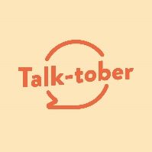 | Do you know the signs of an unhealthy teen relationship? Does your teen? Today is the first day of “Let’s Talk” Month. Join us in making October “Talk-tober.” Anytime is a good time for a talk about sex and relationships. For tips, see link in bio.  #thetalk #thebirdsandthebees #teen #healthy #relationships #relationshipgoals #juniorhigh #middleschool #highschool #parenting #parentingtips
2  Teen | What’s more awkward than talking with your partner about whether or not to have sex? Talking with them about an unplanned pregnancy or sexually transmitted disease! Teens, it’s time to have “the talk.”  https://pcaiowa.org/lets-talk-teens/ | What’s more awkward than talking with your partner about whether or not to have sex? Talking with them about an unplanned pregnancy or sexually transmitted disease! Teens, it’s time to have “the talk.” See link in bio.  #thetalk #thebirdsandthebees #safesex #teen #healthy #relationships #relationshipgoals #juniorhigh #middleschool #highschool #awkward
3  Adult | Healthy relationships start with healthy conversations. And healthy conversations should include consent. Make sure the teens in your life understand that they have the power to decide when they’re ready to have sex, or if they want to wait. https://pcaiowa.org/lets-talk-adults  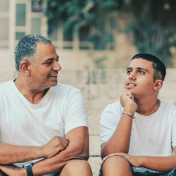 | Healthy relationships start with healthy conversations. And healthy conversations should include consent. Make sure the teens in your life understand that they have the power to decide when they’re ready to have sex, or if they want to wait.  #thetalk #thebirdsandthebees #teen #healthy #relationships #relationshipgoals #juniorhigh #middleschool #highschool #parenting #parentingtips
4  Teen | Look, we get it – talking about sex and relationships can be hard. Don’t get discouraged, though. Just stay in the moment and know that YOU’RE IN CONTROL. Need conversation starters? Look here: https://pcaiowa.org/lets-talk-teens/ | Look, we get it – talking about sex and relationships can be hard. Don’t get discouraged, though. Just stay in the moment and know that YOU’RE IN CONTROL. Need conversation starters? See link in bio.  #thetalk #thebirdsandthebees #safesex #teen #healthy #relationships #relationshipgoals #juniorhigh #middleschool #highschool
5  Adult | We’re halfway through “Talk-tober.” Have you had “the talk” with the teens in your life? We get it. It’s not easy, so here are some conversation-starters: https://pcaiowa.org/lets-talk-adults  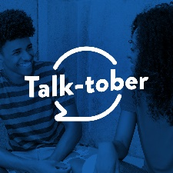 | We’re halfway through “Talk-tober.” Have you had “the talk” with the teens in your life? We get it. It’s not easy, so find conversation-starters in the link in our bio.  #thetalk #thebirdsandthebees #teen #healthy #relationships #relationshipgoals #juniorhigh #middleschool #highschool #parenting #parentingtips
6  Teen | Talking with your partner about sex isn’t just about sex. It’s about respecting yourself and your partner. It’s about your safety. It’s about your future! Here’s how to make having “the talk” easier for everyone: https://pcaiowa.org/lets-talk-teens/ | Talking with your partner about sex isn’t just about sex. It’s about respecting yourself and your partner. It’s about your safety. It’s about your future! See the link in our bio for tips on making “the talk” easier for everyone.  #thetalk #thebirdsandthebees #safesex #teen #healthy #relationships #relationshipgoals #juniorhigh #middleschool #highschool
7  Adult | When it comes to sex and healthy relationships, did you know kids are almost as likely to listen to an adult (35%) as they are their friends (39%)? They’re listening; it’s time to have “the talk.” https://pcaiowa.org/lets-talk-adults | When it comes to sex and healthy relationships, did you know kids are almost as likely to listen to an adult (35%) as they are their friends (39%)? They’re listening; it’s time to have “the talk.” See link in bio.  #thetalk #thebirdsandthebees #teen #healthy #relationships #relationshipgoals #juniorhigh #middleschool #highschool #parenting #parentingtips
8  Teen | Who decides when it’s okay to have sex? Your partner? Your parent? Your doctor? Nope. It’s YOU! If you’re not ready, talk to your partner. Respecting each other’s boundaries and discussing possible outcomes is part of a healthy relationship. Read more here:  https://pcaiowa.org/lets-talk-teens/ | Who decides when it’s okay to have sex? Your partner? Your parent? Your doctor? Nope. It’s YOU! If you’re not ready, talk to your partner. Respecting each other’s boundaries and discussing possible outcomes is part of a healthy relationship. Read more at the link in our bio.  #thetalk #thebirdsandthebees #safesex #teen #healthy #relationships #relationshipgoals #juniorhigh #middleschool #highschool

