Post | Facebook | Instagram
1 | Whether it’s your child or your grandparent, ANYONE and EVERYONE benefits from positive relationships … especially during times like these. For some simple ways to make more positive connections, visit ConnectionsMatter.org  #connectionsmatter #coronavirus #covid19 #covid #whatsyourconnection  IMAGE:  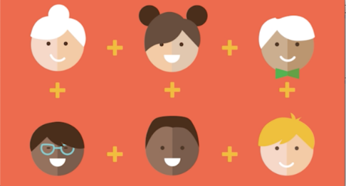 | Whether it’s your child or your grandparent, ANYONE and EVERYONE benefits from positive relationships … especially during times like these. For some simple ways to make more positive connections, click the link in our bio  #connectionsmatter #coronavirus #covid19 #covid #positivevibes #positivity #whatsyourconnection  IMAGE:  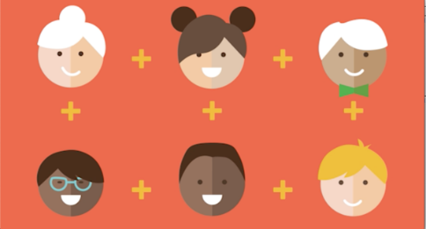
2 | Social distancing doesn’t mean we can’t be distantly social. So check in on an old friend. Share a meal with a neighbor. Honk outside the home of someone you love. Positive relationships are proven to make us healthier and happier. Now go ahead – make someone’s day!  #socialdistancing #distantlysocial #connectionsmatter #coronavirus #covid19 #covid #whatsyourconnection  IMAGE:  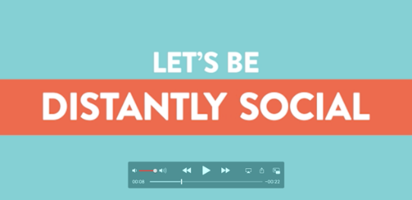 | Social distancing doesn’t mean we can’t be distantly social. So check in on an old friend. Share a meal with a neighbor. Honk outside the home of someone you love. Positive relationships are proven to make us healthier and happier. Now go ahead – make someone’s day!  #socialdistancing #distantlysocial #connectionsmatter #coronavirus #covid19 #covid #positivevibes #positivity #whatsyourconnection  IMAGE:  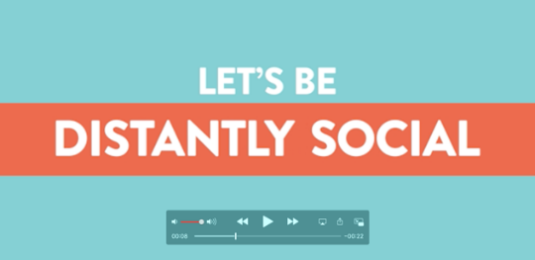
3 | In times like these, we could all use a positive connection. Tag the friend(s) who always brings a ray of sunshine. ️  #connectionsmatter #coronavirus #covid19 #covid #whatsyourconnection  IMAGE:   | In times like these, we could all use a positive connection. Tag the friend(s) who always brings a ray of sunshine. ️  #connectionsmatter #coronavirus #covid19 #covid #positivevibes #positivity #whatsyourconnection  IMAGE:
4 | Is social distancing making you feel disconnected from the world? Here are 5 ways to reconnect with the people in your circle:  - Grab a virtual coffee with a friend.  - Bring a meal to a neighbor.  - Identify 3 “cheerleaders” to a) lean on when you’re stressed and b) celebrate good times with.  - Talk to a teen about … anything!  - Take a tech break from your phone and do a driveway hangout with a friend … 6 feet apart, of course .  For more ideas, visit ConnectionsMatter.org  #connectionsmatter #coronavirus #covid19 #covid #whatsyourconnection  IMAGE:  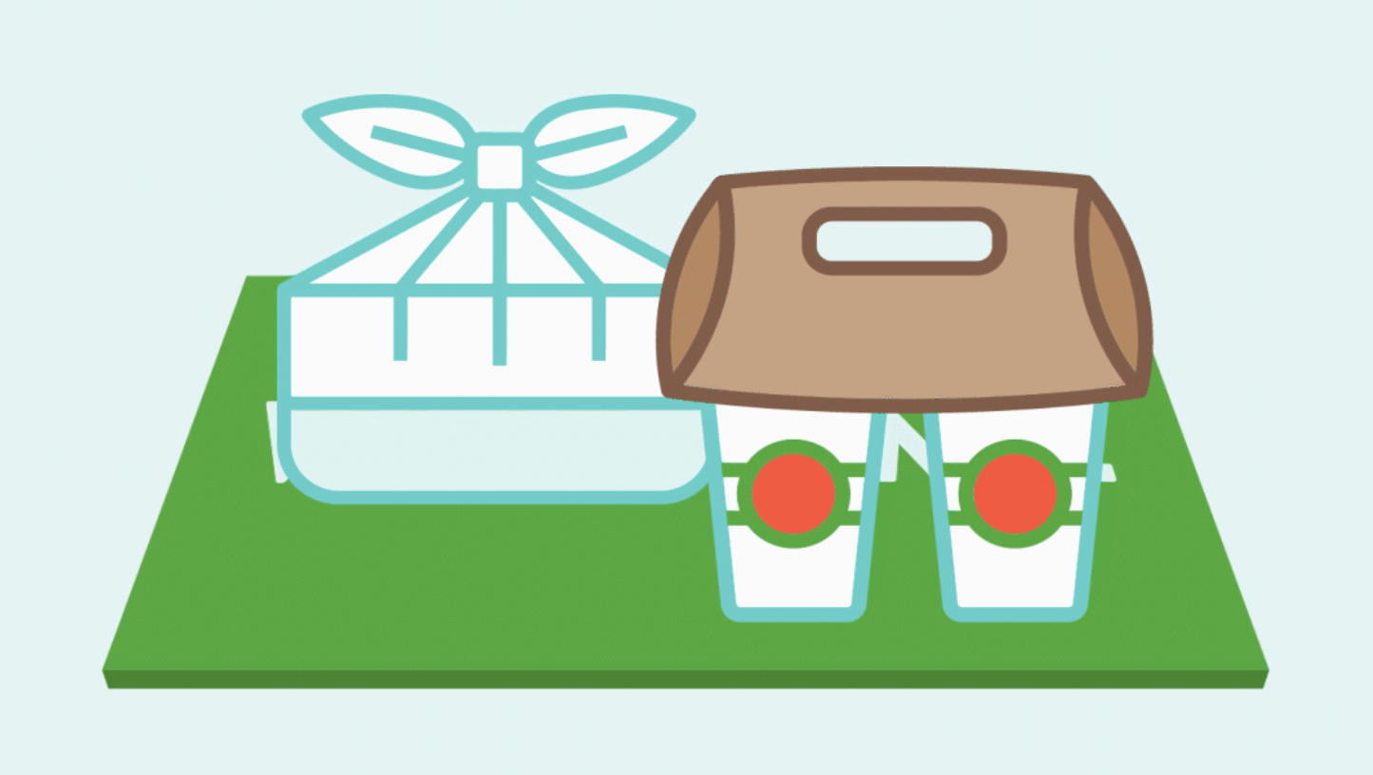 | Is social distancing making you feel disconnected from the world? Here are 5 ways to reconnect with the people in your circle:  - Grab a virtual coffee with a friend.  - Bring a meal to a neighbor.  - Identify 3 “cheerleaders” to a) lean on when you’re stressed and b) celebrate good times with.  - Talk to a teen about … anything!  - Take a tech break from your phone and do a driveway hangout with a friend … 6 feet apart, of course .  For more ideas, click the link in our bio  #connectionsmatter #coronavirus #covid19 #covid #positivevibes #positivity #whatsyourconnection  IMAGE:
5 | Don’t underestimate the power of positive connections. They help children’s brains develop. They make all of us happier and more resilient. And happy, healthy people create a stronger community! So while it’s ok to feel down, make time for some positivity. For help, visit ConnectionsMatter.org  #connectionsmatter #coronavirus #covid19 #covid #whatsyourconnection  IMAGE:   | Don’t underestimate the power of positive connections. They help children’s brains develop. They make all of us happier and more resilient. And happy, healthy people create a stronger community! So while it’s ok to feel down, make time for some positivity. For help, click the link in our bio.  #connectionsmatter #coronavirus #covid19 #covid #positivevibes #positivity #whatsyourconnection  IMAGE:  
6 | Less crime, violence and drug abuse. Fewer people with mental health issues. More success in school. If it all sounds like a dream, know this – the more positive connections we make throughout our community, the more likely that dream becomes our reality. To see how little things can make a big difference, visit ConnectionsMatter.org.  #connectionsmatter #whatsyourconnection  IMAGE:  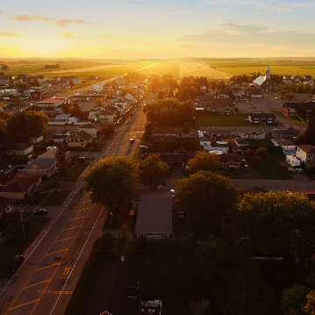 | Less crime, violence and drug abuse. Fewer people with mental health issues. More success in school. If it all sounds like a dream, know this – the more positive connections we make throughout our community, the more likely that dream becomes our reality. To see how little things can make a big difference, click the link in our bio.  #connectionsmatter #positivevibes #positivity #whatsyourconnection  IMAGE:  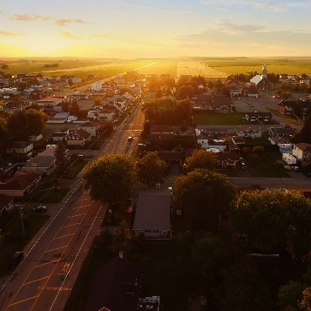
7  Post on a Monday | It’s simple really.  #connectionsmatter #Mondaymotivation #whatsyourconnection  IMAGE:  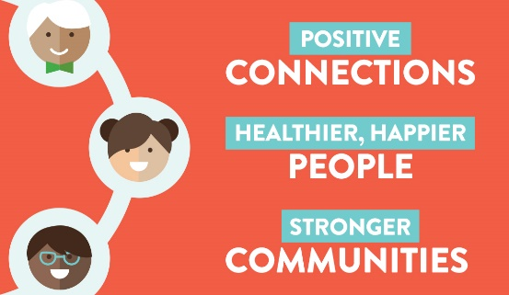 | It’s simple really.  #connectionsmatter #Mondaymotivation #positivevibes #positivity #whatsyourconnection  IMAGE:  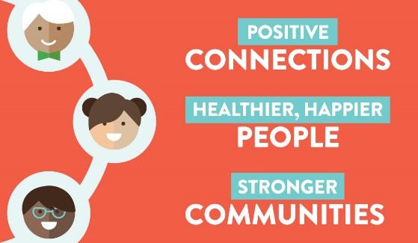
8 | “Every child is one caring adult away from being a success story.” - @Josh Shipp  You have the power to make a positive difference in a child’s life. Invest time with them. Get to know them. Let them know you see their potential.  #powerofpositivity #connectionsmatter #whatsyourconnection  IMAGE:  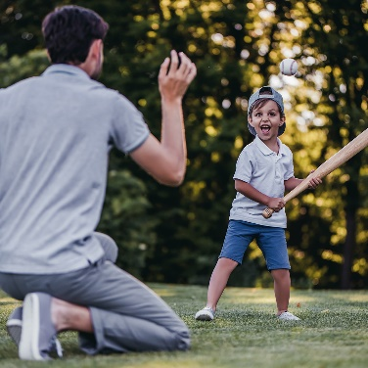 | “Every child is one caring adult away from being a success story.” - @JoshShipp  You have the power to make a positive difference in a child’s life. Invest time with them. Get to know them. Let them know you see their potential.  #connectionsmatter #positivevibes #positivity #whatsyourconnection  IMAGE:  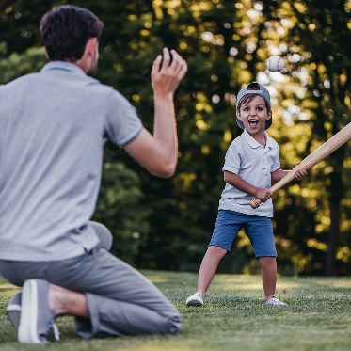
9 | Spending quality time with children is important for their development. The following simple activities can provide support and strengthen children’s brains:  - Sing songs  - Give hugs and affection  - Read stories  - Play games  #connectionsmatter #coronavirus #covid19 #covid #whatsyourconnection  IMAGE:  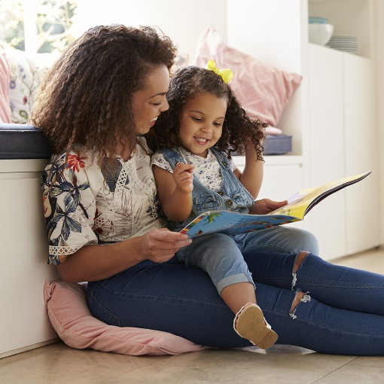 | Spending quality time with children is important for their development. The following simple activities can provide support and strengthen children’s brains:  - Sing songs  - Give hugs and affection  - Read stories  - Play games  #connectionsmatter #coronavirus #covid19 #covid #positivevibes #positivity #whatsyourconnection  IMAGE:  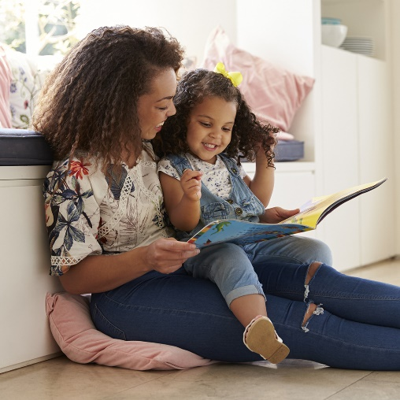
10 | QUIZ: Which of the following are proven benefits of having positive relationships?  - Less likely to be depressed.  - Feeling rich.  - Lower blood pressure.  - Less likely to get sick.  The answer: All of the above. So go on – make a positive connection today!  #connectionsmatter #whatsyourconnection  IMAGE:  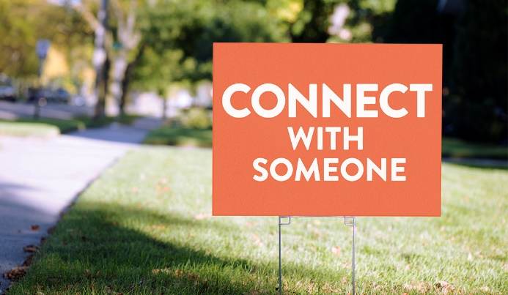 | QUIZ: Which of the following are proven benefits of having positive relationships?  - Less likely to be depressed.  - Feeling rich.  - Lower blood pressure.  - Less likely to get sick.  The answer: All of the above. So go on – make a positive connection today!  #connectionsmatter #positivevibes #positivity #whatsyourconnection  IMAGE:
11 | Need to talk with someone, but not sure where to turn? Call 2-1-1. It’s a service staffed by caring professionals who help millions of people in need across the country every year.  #connectionsmatter #coronavirus #covid19 #covid #whatsyourconnection  IMAGE:  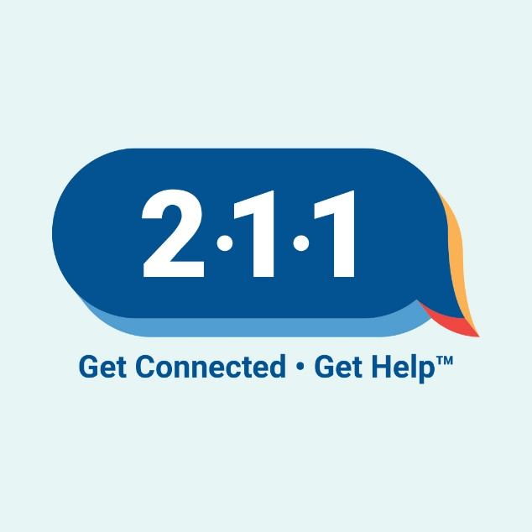 | Need to talk with someone, but not sure where to turn? Call 2-1-1. It’s a service staffed by caring professionals who help millions of people in need across the country every year.  #connectionsmatter #coronavirus #covid19 #covid #whatsyourconnection  IMAGE:  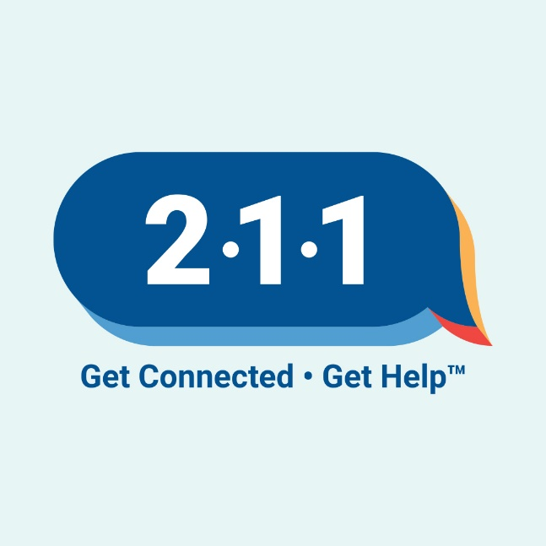
12 | Where do you turn when you need a pick-me-up? Get active? Grab a cup of coffee? Go to a trusted friend? All are good choices. Here’s another: ConnectionsMatter.org. There you’ll find ideas on starting and maintaining positive connections in your life.  #connectionsmatter #whatsyourconnection  IMAGE:  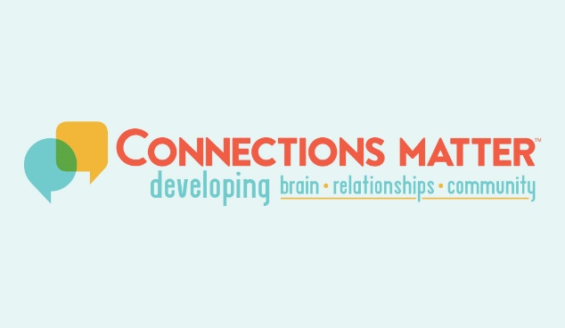 | Where do you turn when you need a pick-me-up? Get active? Grab a cup of coffee? Go to a trusted friend? All are good choices. Here’s another: ConnectionsMatter.org. There you’ll find ideas on starting and maintaining positive connections in your life.  #connectionsmatter #positivevibes #positivity #whatsyourconnection  IMAGE:  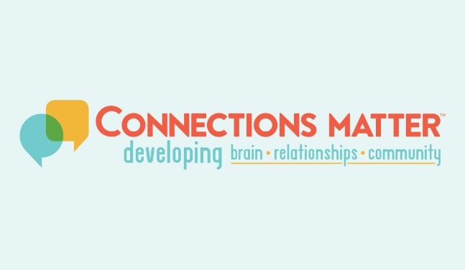

Important Note about Instagram Bios & Links

- For posts that direct visitors to your Instagram bio page for a link to more information, please update your bio to include a link to www.ConnectionsMatter.org

